**New Session @ New Location**

**Columbia College Fair**

|  |
| --- |
| **Aug. 27 , 2016 (SAT) 10:00 am ~ 2:oo pm**  **Tysons Campus Auditorium**  **8620 Westwood Center Dr. Vienna, VA 22182**  **(703) 206 – 0508**  **RSVP: Sunk@ ccdc.edu** |

**Grab Your Future!**

C:\Program Files\Microsoft Office\MEDIA\CAGCAT10\j0293844.wmf

* **Free Application for Federal Student Aid**

(Financial Aid is available to those who qualify)

* **Veterans Education Benefits available**
* **F1, J-1 Visa Consulting**

|  |  |  |
| --- | --- | --- |
| **Time** | **Programs** | |
| **10:00 am ~ 11:30 am** | **• Dental Laboratory Technology • Massage Therapy**  **• Cosmetology • Culinary Arts • Nurse Aide** | **• ESL**  **• Online ESL** |
| **11:30 am ~ 12: 30 pm** | **Financial Aid, Veterans Education**  **F-1, J-1 visa Consulting** |
| **12:30 pm ~ 2:00 pm** | **• Business Administration • Computer Science**  **• Education • Technical and Business English • TESOL** |

|  |  |
| --- | --- |
| **Centreville Campus Fair**  5940 Centreville Crest Ln.  Centreville, VA 20121  **(703) 266-0508** | **Aug, 25 (Thu.)**  **5:30 pm ~ 7:30 pm** |
| **Silver Spring Campus Fair**  12125 Veirs Mill Rd.  Silver Spring, MD 20906  **(301) 929-0565** | **Aug, 25 (Thu.)**  **5:30 pm ~ 7:30 pm** |

**• Voucher ($50) for Application fee**

**• Drinks, Snack and Souvenirs**

**• Free Manicure & Chair Massage**

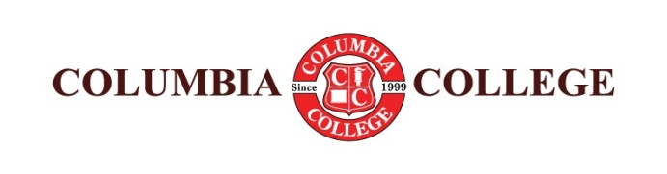

[**www.ccdc.edu**](http://www.ccdc.edu)

**facebook.com/ccdcedu blog.naver.com/ccdc1999**